# **GDD – Peryton University**

Caerwyn Bartley: Designer

Corey Bloomfield: Designer

Alex Smits: Designer

Mitchell Bonham: Programmer

Alexander O'Dea: Artist

Contents

GDD – Peryton University 1

Project Overview – Peryton University 5

1-Line Summary 5

Description 5

Target Market 5

Competitor Analysis 5

Design Pillars 7

Gameplay Design 7

Synopsis of Gameplay 7

Game Mode – Story Mode 8

Description 8

Objectives / Goals 8

Game Loops 8

￼

Game Mechanics 9

Mechanics List 9

Interaction - Interact with world items 10

Interaction - Interact with characters 10

UI – Main Menu 10

UI – In-Game Menu 11

UI – Dialogue Menu 11

UI – Social Cards 11

Character Controller - Character 12

Character Controller - Camera 12

Character Controller - Cutscenes 13

Rules & Systems 13

No fail-state: 13

Starting Social Card 13

Game Economy 13

Economy List 13

Amount of Social Cards 13

User Interface & Controls 15

User Interface Design 15

Main Menu 15

In-Game Menu 15

Narrative Card UI 15

Feedback Systems 16

Controls 17

Game Content 18

Content Types 18

Dialogue Social Cards 18

Characters 18

Project Overview – Peryton University

### 1-Line Summary

A narrative based card game in which you play a socially anxious college freshman and must build up your confidence to approach an estranged friend at a party.

### Description

You are a freshman in college attending a house party in which you don’t know anyone, you are socially anxious and struggling to fit in. The game sees you taking small steps interacting with people and collecting social cards used to engage in dialogue. The goal is to collect all social cards and have the confidence to approach an estranged friend who is at the party.

Key NPCs around the party provide the player with a new social card upon a successful conversation. The player will have to tailor their responses in dialogue to suit the conversation. Obtaining and choosing the correct social card in conversation is the central gameplay loop.

### Target Market

* Young adults, between the ages of 18 to 25
* People who have experienced difficult situations / stressful issues
* Socially anxious individuals and people with communication barriers
  + Requires consideration for the extremely personal and vulnerable subject matter
  + Due to the wide and Diverse target market, there should be an emphasis on accessibility

### Competitor Analysis

**Afterparty**

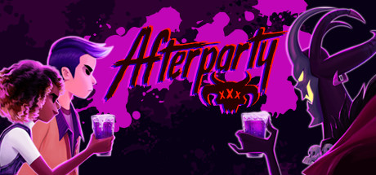

<https://store.steampowered.com/app/762220/Afterparty/>

**Summary**

In Afterparty, you are Milo and Lola, recently deceased best buds who suddenly find themselves staring down an eternity in Hell. But there's a loophole: outdrink Satan and he'll grant you re-entry to Earth.

**Genre**

Choice Driven Narrative

**Platform**

WINDOWS, OS X, LINUX, PS4, XBOX ONE, SWITCH

**Relevance to Project**

* Dialogue driven puzzles with mini-game inclusions
* Similar theme being ‘relationships’ explored through narrative

**Monster Prom**

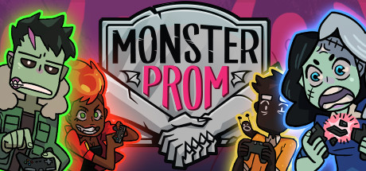

<https://store.steampowered.com/app/743450/Monster_Prom/>

**Summary**

You have 3 weeks to get a date for Monster Prom! Go through absurd and funny situations, raise your stats and seduce one of your classmates. Beautiful art, bold, unapologetic dialogue and hard choices make up this Multiplayer (1-4 players) Dating Sim. Be your worst self.

**Genre**

Comedy Dating Simulator

**Platform**

WINDOWS, OS X, LINUX, SWITCH

**Relevance to Project**

* Design of dialogue system
* Monster character concepts, personality/character archetypes

### Design Pillars

* **Card-Based gameplay**
  + Use social cards as talking points in a conversation
  + Earn social cards from successful conversation
* **Narrative Exploration**
  + Discovering new characters to discuss with
  + Discovering new social cards to use in conversations
* **Self-Empowerment / Positivity**
  + No fail states
  + Focus on maintaining a positive mindset and self-improvement

## Gameplay Design

### Synopsis of Gameplay

The core gameplay loop requires the player to explore the surrounding area and experiment by talking to different NPCs. This involves using available social cards in dialogue and testing to see what approach will work on each character. At times, the player will be forced into insurmountable dialogue, in which they cannot continue. This will require the player to double back and experiment on past NPCs with any new social cards they have obtained since. Once the player has successfully obtained the necessary social cards and has reached a favourable outcome in dialogue, they will receive a new social card as a reward and be able to advance.

The overarching goal that incentivises the player to continue is initially reaching their estranged friend who is also attending the party. As the player progresses this goal becomes slightly altered; having the estranged friend enter an area that is currently unreachable for the player. This requires the player to explore and build their confidence to gain enough presence and courage to reach the estranged friend.

Game Mode – Story Mode

Description  
The player walks around the level and talks to characters by using different social cards they have earnt up until that point. As the player interacts with NPCs and continues to build their confidence, they learn about their backstories and character motivations. Slowly, the player character begins to gain confidence (in the form of new social cards being added to the players hand) and become more socially adept.

Objectives / Goals

* **Grow your confidence**
  + Collect all the available social cards
  + Have successful conversations with all interactable characters
* **Catch up with and talk to estranged friend (Victory Condition)**
  + Moves around the level out of player’s reach
  + Requires the player to have a successful conversation with all other interactable characters and gain all available social cards.

#### Game Loops

#### 

### Game Mechanics

Mechanics List

* Interaction
  + World items
  + Characters
* User Interface
  + Main Menu
  + In-Game Menu
  + Settings
  + Dialogue screen
  + Social Cards
* Character Controller
  + 3D isometric camera
  + Walking
  + Cutscenes
* Dialogue
  + Card-based dialogue choice
  + Character portraits conveying emotions

#### Interaction - Interact with world items

**Summary:** When the player presses the interaction key they interact with an item in the world if they are standing in front of it and it is being prompted.

**Details:**

* Must be standing close / in front of item
* Interacting with item will trigger a form of feedback (e.g., door opening sound + animation)
* Could also trigger a cutscene
* To show that the item is selected it is highlighted and particles emanate from the item.

**Related mechanics & systems:**

* Character Controller
* Cutscene

#### Interaction - Interact with characters

**Summary:** When the player presses the interaction key they interact with a character if they are standing next to them.

**Details:**

* Key characters will be able to engage in dialogue with the player
* By interacting with a character, dialogue begins
* Not all characters can be interacted with, some are background shades.
* Whether or not a character can be interacted with is shown by the character having a distinctive colour, along with being highlighted and having particles emanating when selected.

**Related mechanics & systems:**

* Dialogue
* User Interface - Dialogue Menu

#### UI – Main Menu

**Summary:** The main menu for the game, used to start the game, change settings, look at the credits and quit the game.

**Details:**

* Play game button - starts the game.
* Credits button - links to the credits UI menu.
* Exit game - closes the game to desktop.

**Related mechanics & systems:**

* User Interface - Credits
* User Interface – Settings

#### UI – In-Game Menu

**Summary:** The in-game menu for the game, used to pause the game, change settings, return to main menu and quit the game.

**Details:**

* Continue button – closes the in-game menu (The ‘escape’ key also does this).
* Main Menu button – exits the game and returns to main menu (warning and confirmation popup to ensure no accidental clicking).
* Exit Game button – exits the game to the desktop (warning and confirmation popup to ensure no accidental clicking).

**Related mechanics & systems:**

* User Interface - Main Menu

#### UI – Dialogue Menu

**Summary:** The dialogue menu appears when interacting with a character.

**Details:**

* Sprite of the character
* Text box
* Character's opinion of player
* Portrait of player character
* Different coloured text (messenger style) for different characters
* Mouse is unlocked and visible while the UI is open.

**Related mechanics & systems:**

* User Interface - Social Cards
* Social Cards
* Interaction with characters
* Cutscenes

#### UI – Social Cards

**Summary:** Social Cards are played in dialogue to engage in conversation. The player must earn social cards by successfully interacting with NPCs.

**Details:**

* View available social cards that the player has obtained.
* Mouse is unlocked and visible while the UI is open.
* The player must correctly identify and use the correct social cards to successfully complete the dialogue.
* Using the wrong social card will either offer a new set of dialogue or will end the dialogue with the character.
* There are multiple stages of the conversation, requiring the player to use up to 2 social cards during the dialogue interaction. (This could increase to add complexity)

**Related mechanics & systems:**

* Interaction with characters
* Cutscenes
* User Interface – Dialogue

#### Character Controller - Character

**Summary:** Third person character controller, ability to interact with items and characters.

**Details:**

* Can’t jump
* Press a key to interact that’s contextual (item or character)
* Walking pace (should be modifiable)
* Frozen when in-game menu is open
* Frozen when dialogue menu is open

**Related mechanics & systems:**

* Interaction
* Camera

#### Character Controller - Camera

**Summary:** 3D isometric, fixed rotation, follows player.

**Details:**

* Follows the player (player centre)
* No rotation.
* Can pan during cutscenes to focus on various parts of the level.
* Frozen when in-game menu is open
* Frozen when dialogue menu is open

**Related mechanics & systems:**

* Character controller
* Cutscenes

#### Character Controller - Cutscenes

**Summary:** 3D isometric, fixed rotation, follows player.

**Details:**

* Follows the player (player centre)
* No rotation.
* Can pan during cutscenes to focus on various parts of the level.
* Frozen when in-game menu is open
* Frozen when dialogue menu is open

**Related mechanics & systems:**

* Character controller
* Cutscenes

### Rules & Systems

#### No fail-state:

* The game is focused on themes of empowerment and positive outlooks, therefore having a fail-state in the game would be counter-intuitive and detrimental to the overall experience of building confidence. Instead of punishing the player for failing, the act of trial and error and learning through failure will be pushed onto the player and conveyed as a positive approach to dealing with stressful situations.

#### Starting Social Card

* Silence (…)

### Game Economy

#### Economy List

* Number of social cards

#### Amount of Social Cards

**Economy overview:**

Social cards used to engage in dialogue with different approaches. These are earnt by the player upon successful conversations with NPC’s and correlate to the player’s confidence level.

**Details:**

* The player starts with only one social card, that social card being ‘Silence’ (Ellipsis)
* To earn more social cards and grow their dialogue options the player must increase their confidence by engaging with NPCs in conversation
  + A social card is rewarded through successful conversation
* The player receives 1-2 predetermined social cards depending on the NPC.
  + Most of them will only supply 1
* The rate at which players receive social cards will require manual adjustment after testing in ensure that they are never overwhelming or over-complicated

## User Interface & Controls

### User Interface Design

#### Main Menu

Game Title with several buttons (Play, Exit & Credits) with Play & Exit as cards in the bottom centre and “credits” as plain text in the bottom right. A background of all the characters as shadows except for the main character (Phim), with the logo for the game in the top centre.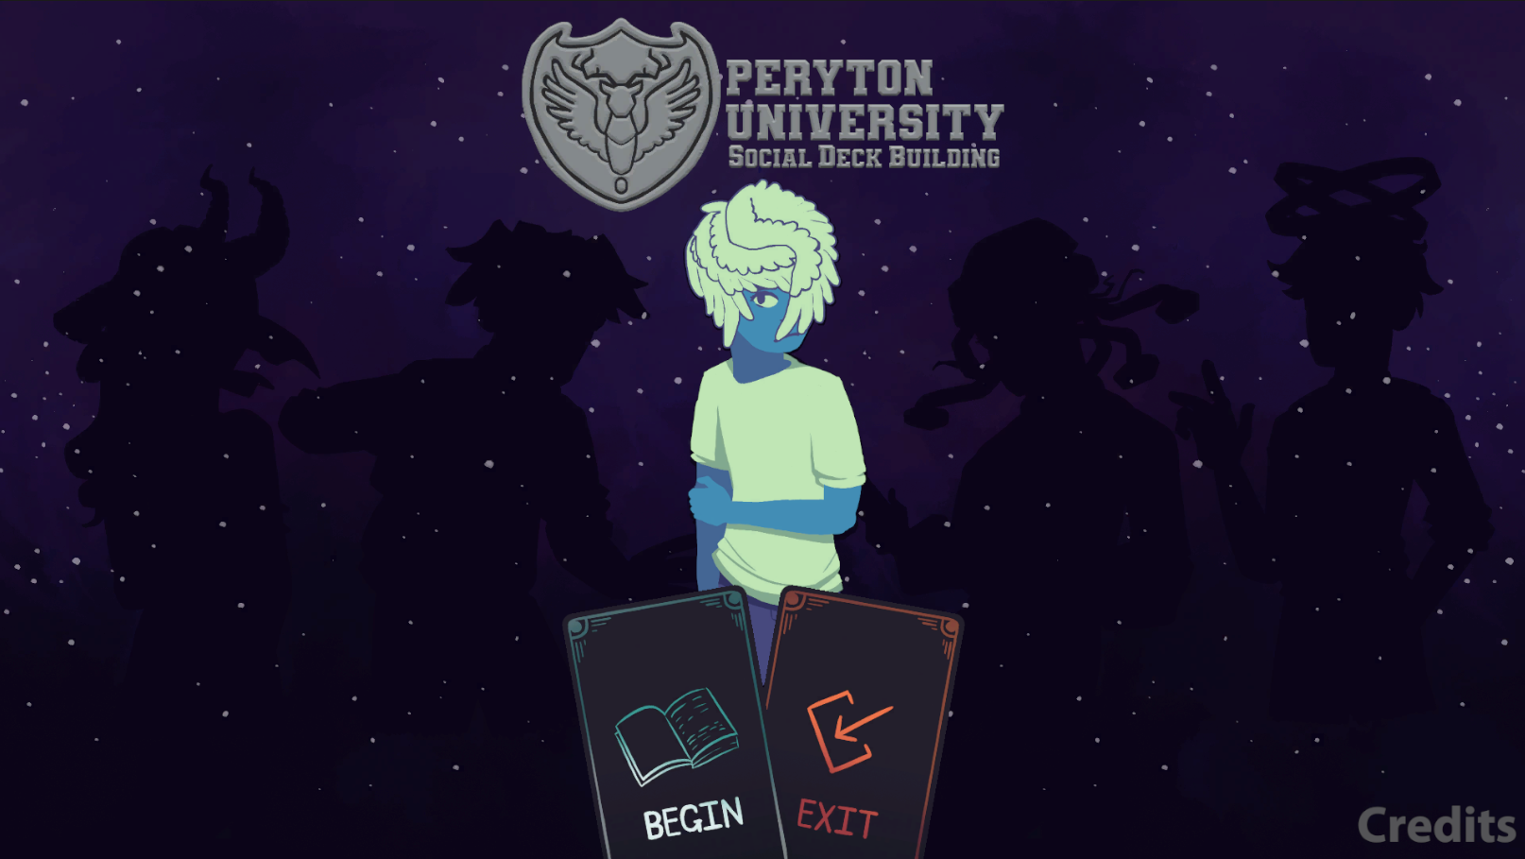

#### In-Game Menu

An in-game menu with the word “PAUSED”, two buttons (Resume & Main Menu) vertically and the game title below in the bottom right corner.

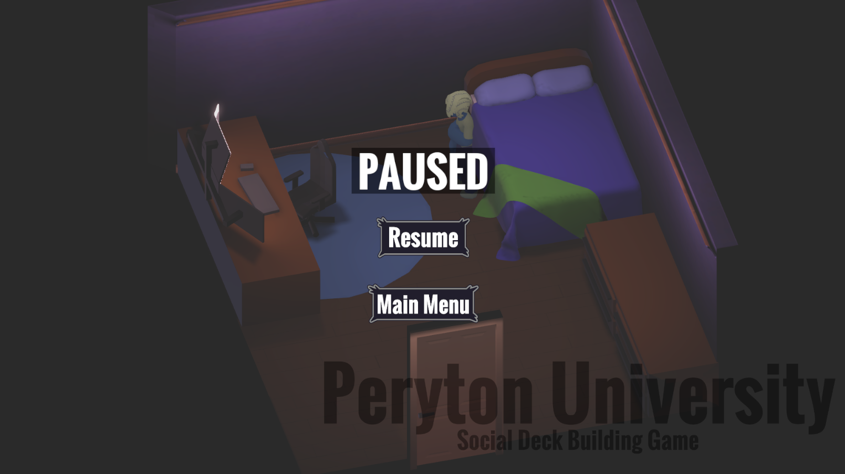

#### Narrative Card UI

Popup user interface for character the player has selected. Contains the players current deck of available social cards to respond to what the character has said. A sprite of the character is also displayed that changes based on their emotions towards the player and which social cards they are playing.

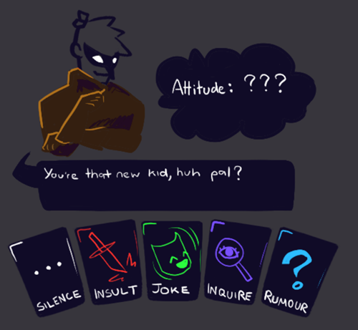

*Concept*

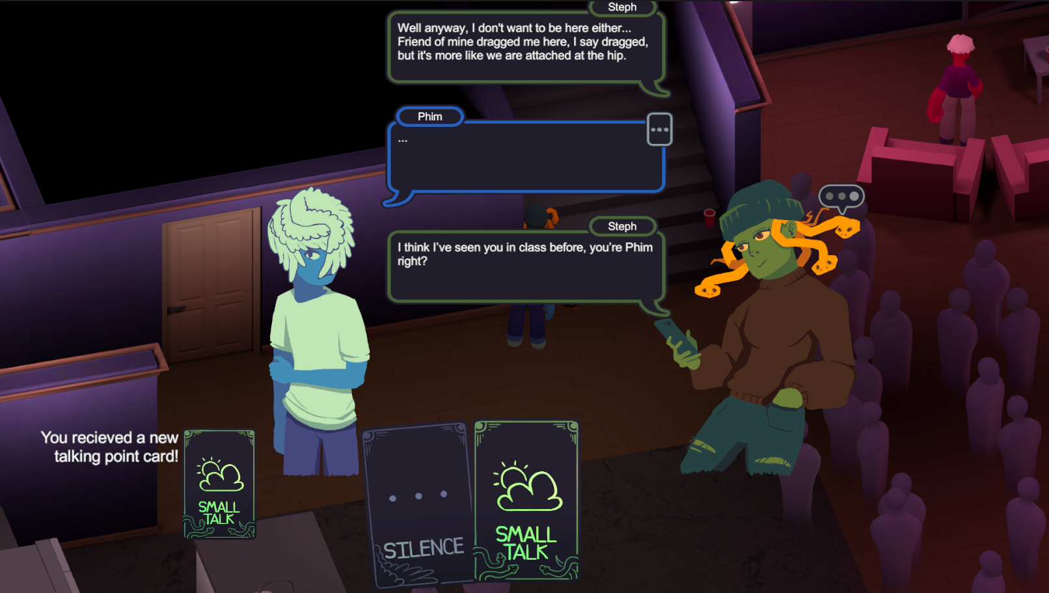

*In-Game Screenshot*

### Feedback Systems

Interaction

* Audio cue played upon successful interaction with object (e.g. SFX with door opening)
* Audio cue upon receiving a new social card (during dialogue)
* Simple animation to visually convey the movement of interacted world objects (e.g. bedroom door)
* Text “E to interact” above interactable object or “E to talk” above an interactable character.

Background Music

* Changes depending on the player’s proximity to the dance floor
  + Clear and loud when close --> muffled and suppressed when far
* Useful for conveying a sense of 3D space and location
* Used to direct the player towards the goal (estranged friend on dance floor)
* Changes from a chill dance song to a more upbeat dj song once the dj starts playing via a cutscene

### Controls

* W, A, S, D
  + Movement buttons (Up, Left, Down, Right)
* E
  + Interact
* Spacebar
  + Advance dialogue
* Escape
  + Open in-game menu
* Left Mouse
  + Select UI button where mouse curser is (when applicable)
  + Select Social Cards during dialogue
  + Advance Dialogue

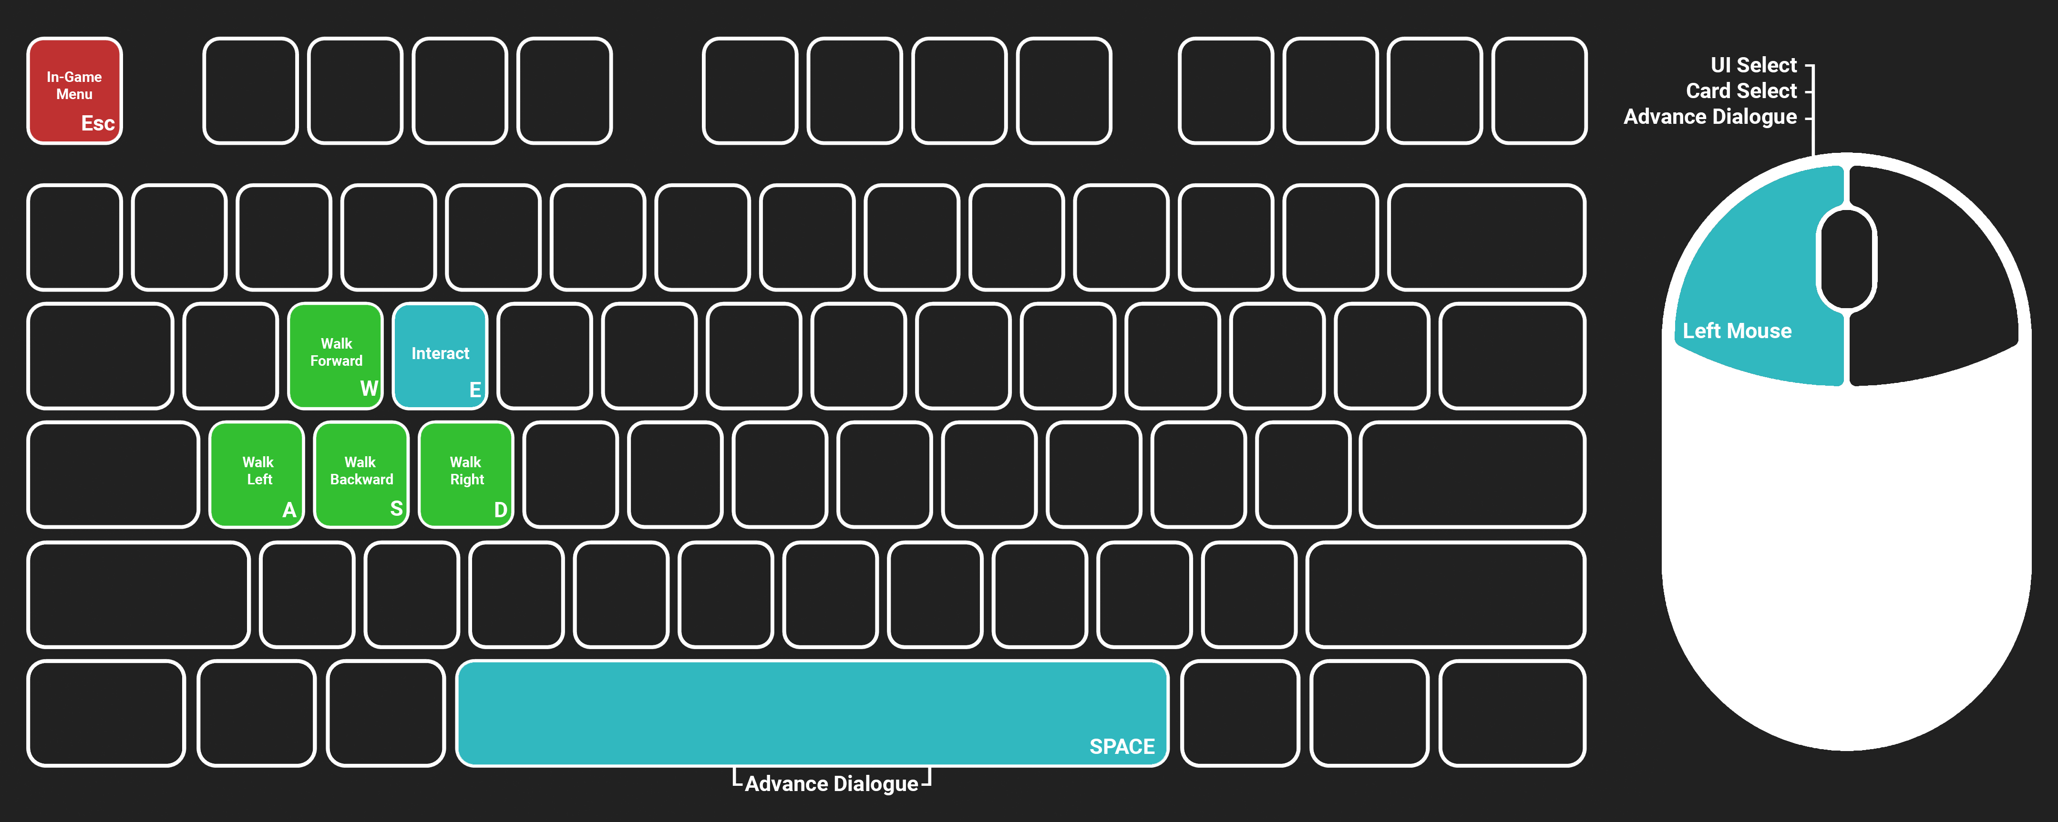

#### 

## Game Content

### Content Types

* Dialogue Social Cards
* Characters
* Rooms (Map)

### Dialogue Social Cards

* Silence (…)
  + Social Card that the player starts the game with
* Joke
  + Received from Budd
* Praise
  + Received from Budd
* Drink Items x3 (drinks received from drunk guy at the food and drinks table)
  + Sour Green Apple
  + Sweet Red Cherry
  + Bitter Red Cranberry
* Comfort
  + Received from Steph
* Small Talk
  + Received from Steph
* Real talk
  + Received from Aurora

### Characters

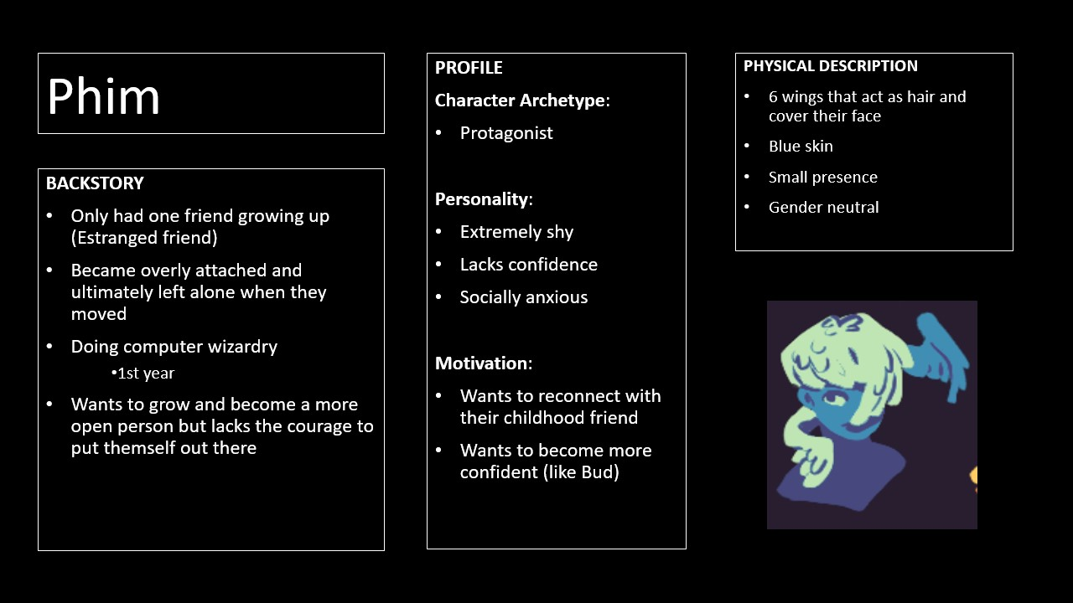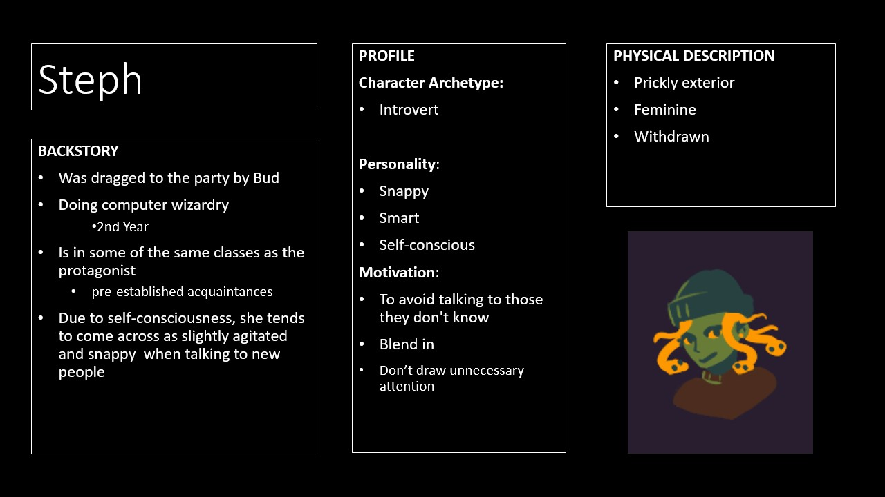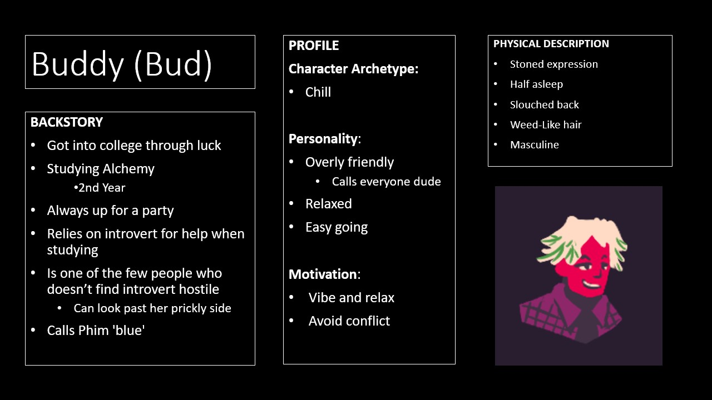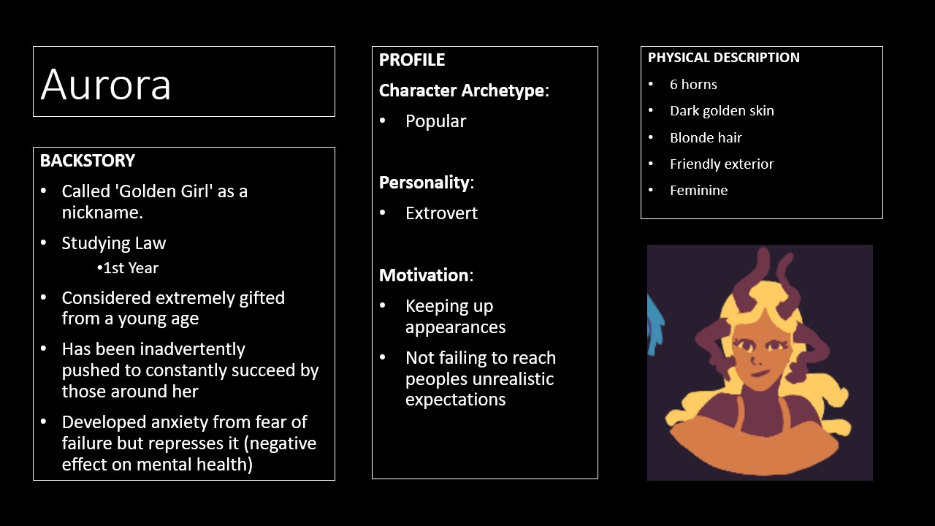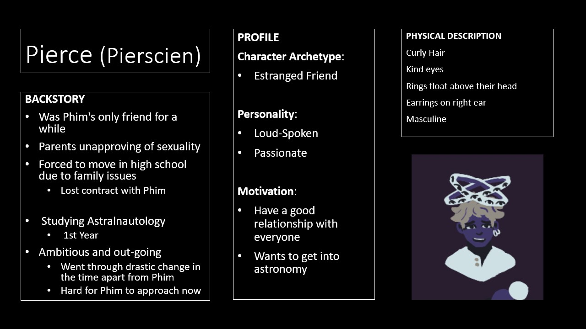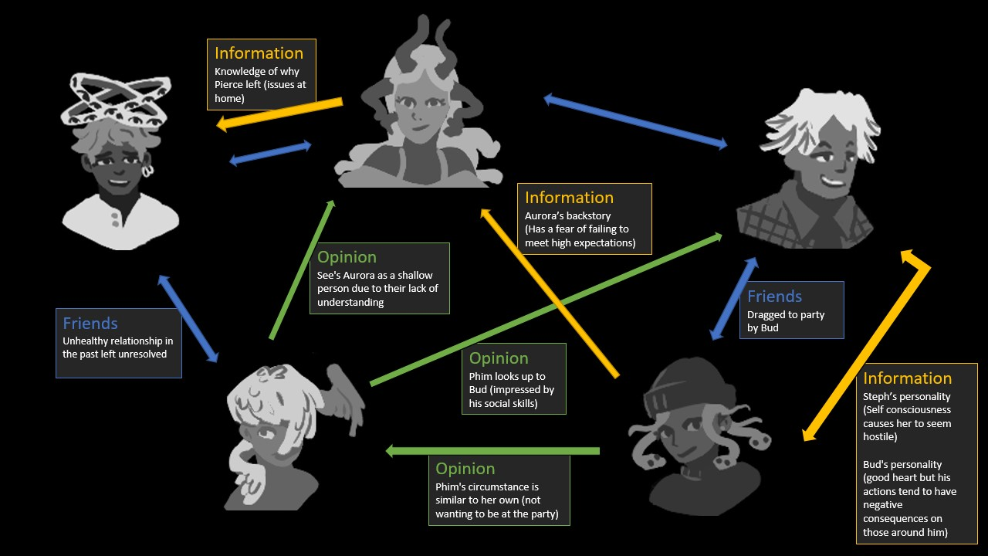

**Map Layout:**

